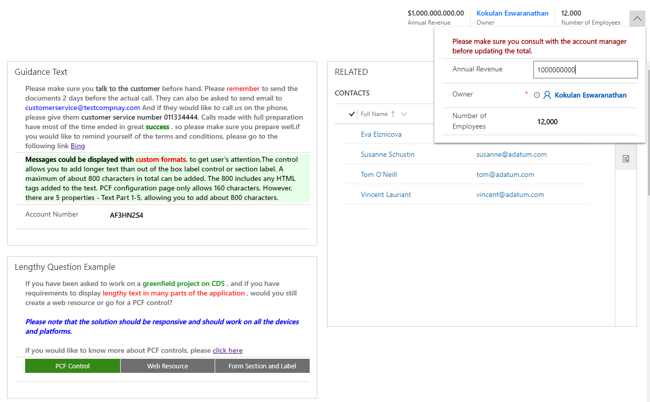

The control can also be used as label for a lengthy label / question with custom styles and links.

The control could also be used for displaying lengthy text for purposes such as information / instruction / other with custom formats and styles as shown in the examples.

The control could be used for displaying text within the header area.